NORTH EASTERN CHAROLAIS CLUB HERDS COMPETITION 2021

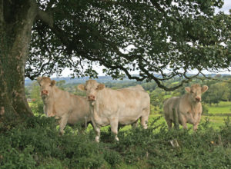
Following on from the success for last year’s herds competition, we are delighted to be able to run the competition again this year. the. Judging of the competition will take place over 2 days, from Saturday the 17th July – Sunday the 18th July, by an independent judge selected by the club. The closing date for entries will be Wednesday the 30th June. Entries can be sent by e-mail to dmagee@kiernanmilling.ie or by post to David Magee, Ardlougher, Ballyconnell, Co. Cavan. The competition will be split into two sections:

- 5 to 15 Cows (Minimum of 5 calves registered includes embryos)
- 15+ Cows
Sections are based on 2020 registrations
Categories – 1st 2nd + 3rd in each Section
- Best Cow with Calf at foot
- Best Bull under 2 years old
- Best Heifer under 2 years old (born on or after 1st Sept 2019)
- Best Heifer under 3 years old (born on or after 1st Sept 2018)
- Best Bull Calf born on or after 1st Sep 2020
- Best Heifer Calf born on or after 1st Sep 2020
- Best Bull Calf born on or after 1st Jan 2021
- Best Heifer Calf born on or after 1st Jan 2021
- Best Group of Calves under a year old

– Entry fee is €30 per herd and must be sent in with the completed entry form. All entrants must be paid up members of the North Eastern Charolais Club and the Irish Charolais Cattle Society
– All stock must be located at the one location for inspection
– Awards night will take place in the autumn (pending Covid 19 restrictions), plaques will be giving to 1st, 2nd & 3rd in each class. Every prize winning animal’s photo will be put up on our website, society’s website and on the NE report in the Charolais Society’s annual book. Similarly, their pedigree and name will also be included.
- There will be an overall 1st, 2nd and 3rd in each sections. In which each winner will receive special plaques.
*Depending on entry numbers we also are thinking of getting a video done on the overall winner of both the Junior and Senior Section which will be shared on social media and Facebook.

