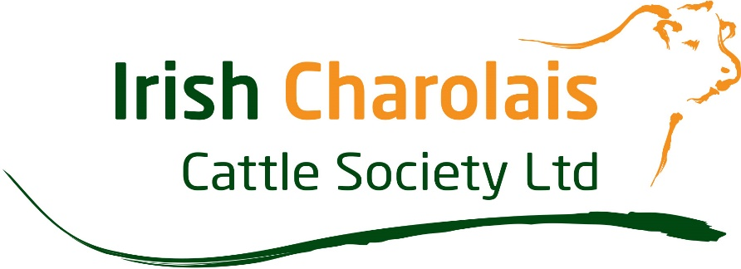
Charolais International YDP Application Form 2022
The Council of the Irish Charolais Cattle Society have decided that once again they will send two young Charolais enthusiasts on a trip of a lifetime in 2022. The lucky pair will get the opportunity to travel to the Charolais International YDP Conference in the United States and represent Ireland on the World Stage. YDP members from Charolais Societies all over the World will be joining them. As well as getting the opportunity to learn all the Stockmanship and Showmanship skills from the best in the business, they will visit some of the best Charolais herds in the United States. Travel, transport, accommodation and meal costs will be covered by the Irish Charolais Cattle Society and Charolais International. The trip will take place from the 26th July – 5th August. All participants must be aged between 18 – 22 years old on the 1^{st of} July of this year to qualify.
There will be two stages in the selection process, you will first need to complete and submit the application form below. This application form can be either typed or written. When completed please submit by e-mail to nevan.charolais@gmail.com or by post to the Irish Charolais Cattle Society, Irish Farm Centre, Bluebell, Dublin 12. The closing date for applications is the 15th April 2022. No late applications will be accepted.
The second stage of the process will take place at the Show and Sale in Tullamore Mart on Saturday the 23rd April, where you will be required to judge pedigree Charolais Cattle, estimate the weights of Cattle and answer a short questionnaire about the Charolais breed.
Please Note:
1. All participants must be aged between 18 – 22 years old on the 1st July 2022
2. Candidates must be a family member or relation of a current Irish Charolais member
3. There must be a minimum number of entrants for the competition to go ahead

Participant Name and Address:
Date of birth:
Contact number:
E-mail address:
Name and herd number of parent or relation who is a current member of the ICCS:
- What are your expectations of the Conference and what do you hope to learn? (Max 250 words)
- Why are you interested in Charolais Cattle and what involvement have you had with Charolais Cattle up until now, if any? (Max 250 words)

- What are your future plans with Charolais Cattle or farming in general? (Max 250 words)
- Please outline how you would promote the Charolais breed in Ireland if you were to become the Marketing manager with the Society in the future? (Max 250 words)

