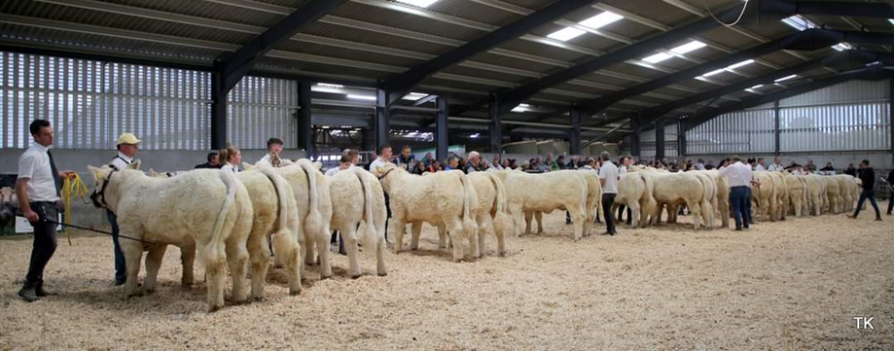
NORTH EASTERN CHAROLAIS CALF SHOW CLASSES – BALLYJAMESDUFF MART – 20TH MAY 2023

PRIZE MONEY: 1st - €100; 2nd - €75; 3rd - €50
Entry fee per animal/entry - €10 (3 entries or more, fee capped at €30)
Class 1: Bull born on or between 1st June 2022 and the 31st August 2022
Class 2: Bull born on or between 1st Sep 2022 and the 31st December 2022
Class 3: Bull born on or after the 1st Jan 2023
Class 4: Heifer born on or between 1st June 2022 and the 31st August 2022
Class 5: Heifer born on or between the 1st Sep 2022 and the 31st December 2022
Class 6: Heifer born on or after the 1st Jan 2023
Class 7: Best pair of calves born on or after the 1st June 2022
Overall North Eastern Charolais Calf Champion (confined to 1st and 2nd prize winners) – Winner will receive a sash and 1 straw of CF52 (Kindly sponsored by CR Solar/ Glera Charolais)
Reserve North Eastern Charolais Calf Champion – Winner will receive €30

ENTRY FORM – NORTH EASTERN CHAROLAIS CALF SHOW - BALLYJAMESDUFF MART - 20th May 2023

CLASS NO. ____________ TAG NO. __________________________________
DATE OF BIRTH __________________ SEX _________
NAME OF ANIMAL __________________________________________________________________________
SIRE______________________________________
DAM_____________________________________ DAM’S SIRE: _____________________________

CLASS NO. ____________ TAG NO. __________________________________
DATE OF BIRTH __________________ SEX _________
NAME OF ANIMAL __________________________________________________________________________
SIRE______________________________________
DAM_____________________________________ DAM’S SIRE: _____________________________

CLASS NO. ____________ TAG NO: __________________________________
DATE OF BIRTH __________________ SEX _________
NAME OF ANIMAL __________________________________________________________________________
SIRE______________________________________
DAM_____________________________________ DAM’S SIRE: _____________________________
NAME & ADDRESS OF EXHIBITOR (PLEASE PRINT) ____________________________________________________________________________________________________________________________
TEL NO.: ______________________ MOBILE NO: _________________________
Entry Fee: €10.00 per animal/entry Closing Date: Strictly, Friday 5th of May, 2023
I agree to accept all the rules, regulations and decisions regarding this Show and certify that the above particulars are true and correct.
Signature of owner/agent/parent_________________________________________________
Please forward completed entry form and fees prior to the 5th of May 2023 to the club secretary: Michael Carey, Sionhill, Killucan, Co. Westmeath
Rules and Regulations for North Eastern Calf Show
- Every exhibitor must be a paid-up member of the North Eastern Charolais Club on the day of the show – membership fee is €20
- Cheque payments for entry fees can be made payable to the ‘North Eastern Charolais Club’
- Every exhibitor must accept that the judge’s decision is final
- All entries must be fully registered in the Irish Charolais Herd Book. All calves must be Irish bred. All purchased cattle must be transferred, through the Irish Charolais Cattle Society office, into the exhibitor’s herd
- All cattle exhibits must be on the show grounds by 11.00am on the morning of the show.
- All animals entered must be halter trained
- Exhibitors will need to bring their own bedding for pens on the day.
- Judging will commence at 12.00 pm unless otherwise stated
- Each breeder must bring the blue card for all animals being shown on the day
- All entries must be in test (TB and BVD) on the day of the show. All necessary documentation must accompany the animal on the day of the show.
- The committee reserves the right to postpone or cancel the show if necessary
- Classes may be cancelled or amalgamated due to insufficient entries.
- The committee delegates full power to the appointed Stewards, to enforce the Rules as set out, and the decision of the committee shall be final in all cases.
- The North Eastern Charolais Club, Ballyjamesduff Mart and the Irish Charolais Cattle Society will not be responsible for any loss, damage, accident or otherwise which may occur to any Exhibitor, Exhibit, Visitor or Vehicle at the Show
- The Judge shall not award a prize in any class where sufficient merit does not appear
- Please do not exhibit animals that are unsuitable with regard to safety e.g. hard to control.
- All animals must be led by a competent handler and the handler must be wearing either a white show coat or shirt in the show ring.
- All exhibitors must have their own public liability insurance policy in the case of an accident occurring
- The North Eastern Charolais Club advise all owners who have their animals insured,
to have the insurance cover extended to cover them while showing animals at shows
- By entering an animal in the show, breeders accept that the Irish Charolais Cattle Society is entitled to take a hair sample for DNA/Genotyping analysis from any animal at the show and also agree to accept and abide by all decisions, rules and regulations regarding the show

